|  |
| --- |
|  |
|  |

|  |  |  |  |  |  |
| --- | --- | --- | --- | --- | --- |
| REVISION HISTORY | | | | | |
| Ver. | Description of Change | Author | Date | Approved | |
| Name | Effective Date |
| 1.0 | Initial status | Olga_Hilko | 04-DEC-2017 |  |  |

Contents

1. DIM tables, sequences on 3NF and grants to BL_CL 3

2. Packages for DIMs (to 3NF) 3

3. Explicit cursor and Merge 4

4. Implicit Cursor 6

# DIM tables, sequences on 3NF and grants to BL_CL

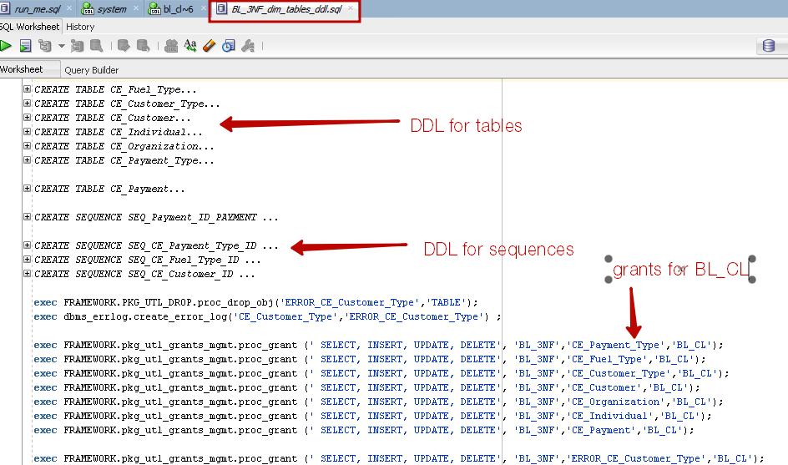

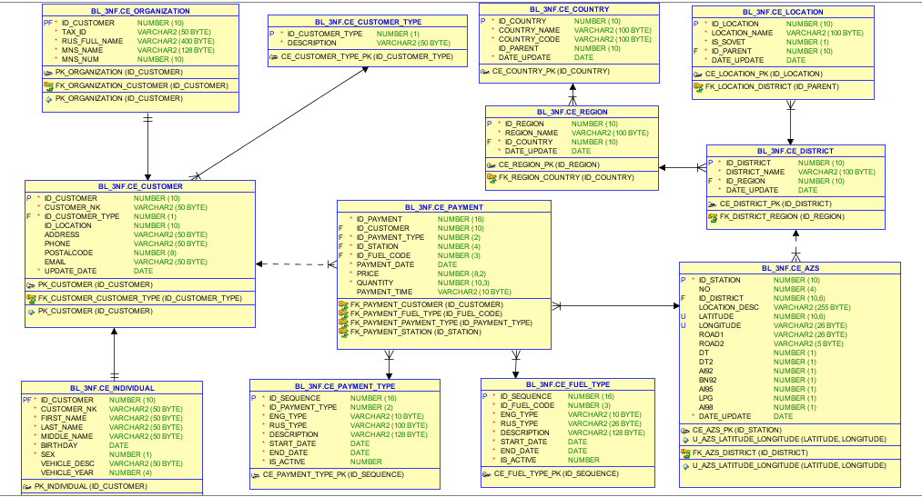

# Packages for DIMs (to 3NF)

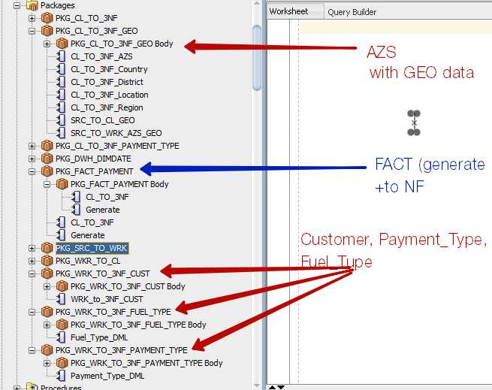

# Explicit cursor and Merge

procedure CL_TO_3NF_AZS

is

cursor cur is (select LONGITUDE, LATITUDE, ID_DISTRICT,DISTRICT_NAME from

(select a.* ,dense_rank() over(partition by LONGITUDE,LATITUDE order by ID_DISTRICT ) r from CL_AZS_MAP_ADDRESS a) t where t.r=1);

-- TYPE t_address

-- IS TABLE OF employees%ROWTYPE

-- INDEX BY PLS_INTEGER;

-- l_employees employees_aat;

sql_stat varchar(400);

before_cnt NUMBER;

after_cnt NUMBER;

table_name varchar(100):='BL_3NF.ce_AZS';

begin

before_cnt := FRAMEWORK.PKG_UTL.get_row_count(table_name) ;

MERGE INTO BL_3NF.ce_AZS nf USING

( select w.No, tmp.ID_DISTRICT , w.LOCATION ,w.LATITUDE, w.LONGITUDE, w.ROAD1, w.ROAD2,

w.DT, w.DT2, w.AI92, w.BN92, w.AI95, w.LPG, w.AI98

FROM WRK_AZS w

left join (select LONGITUDE, LATITUDE, ID_DISTRICT,DISTRICT_NAME from

(select LONGITUDE, LATITUDE, ID_DISTRICT,DISTRICT_NAME ,dense_rank() over(partition by LONGITUDE,LATITUDE order by ID_DISTRICT ) r

from CL_AZS_MAP_ADDRESS) t

where t.r=1) tmp

on tmp.LONGITUDE=w.LONGITUDE and tmp.LATITUDE=w.LATITUDE )

cls ON (

cls.LONGITUDE= nf.LONGITUDE and cls.LATITUDE=nf.LATITUDE

) WHEN MATCHED THEN

UPDATE

SET

nf.No=cls.No, nf.ID_DISTRICT=cls.ID_DISTRICT , nf.Location_Desc=cls.LOCATION ,

nf.ROAD1=cls.ROAD1, nf.ROAD2=cls.ROAD2, nf.DT=cls.DT,

nf.DT2=cls.DT2, nf.AI92=cls.AI92, nf.BN92=cls.BN92,

nf.AI95=cls.AI95, nf.LPG=cls.LPG, nf.AI98=cls.AI98,

date_update=SYSDATE

where

decode(nf.No,cls.No,0,1)+decode(nf.ID_DISTRICT,cls.ID_DISTRICT,0,1)+decode(nf.Location_Desc,cls.LOCATION,0,1)+

decode(nf.ROAD1,cls.ROAD1,0,1)+

decode(nf.ROAD2,cls.ROAD2,0,1)+decode(nf.DT,cls.DT,0,1)+decode(nf.DT2,cls.DT2,0,1)+

decode(nf.AI92,cls.AI92,0,1)+decode(nf.BN92,cls.BN92,0,1)+decode(nf.AI95,cls.AI95,0,1)+

decode(nf.LPG,cls.LPG,0,1)+decode(nf.AI98,cls.AI98,0,1)>0

WHEN NOT MATCHED

THEN INSERT

(ID_Station, NO, ID_DISTRICT, Location_Desc, LATITUDE, LONGITUDE, ROAD1,

ROAD2, DT, DT2, AI92, BN92, AI95, LPG, AI98, date_update)

VALUES

(FRAMEWORK.pkg_utl_seq.seq_getval('BL_3NF.SEQ_CE_AZS_ID'),

cls.NO, cls.ID_DISTRICT, cls.Location, cls.LATITUDE, cls.LONGITUDE, cls. ROAD1,

cls.ROAD2, cls. DT, cls. DT2, cls. AI92, cls. BN92, cls. AI95, cls. LPG, cls. AI98, SYSDATE

);

after_cnt := FRAMEWORK.PKG_UTL.get_row_count(table_name) ;

dbms_output.put_line('Lola: Inserted rows in '||table_name ||' table:' || to_char(after_cnt-before_cnt) || ' row(s)');

end CL_TO_3NF_AZS;

# Implicit Cursor

